Adjective Phrase (AdjP) as Head

🟩 What is Adjective Phrase (AdjP) as Head?
# Source: AI Source: Provided by: [Data Path: Persons Table -> ID Column: 1, Name_En Column: Motasem Essam] -> From: [Chatgpt (GPT‑5 Mini)] on [8/7/2025]
In an Adjective Phrase (AdjP), the head is the main adjective, and it can be accompanied by modifiers or complements. The head adjective determines the syntactic and semantic function of the phrase.

🔹 Common Types of Adjective Phrase Heads
# Source: AI Source: Provided by: [Data Path: Persons Table -> ID Column: 1, Name_En Column: Motasem Essam] -> From: [Chatgpt (GPT‑5 Mini)] on [8/7/2025]
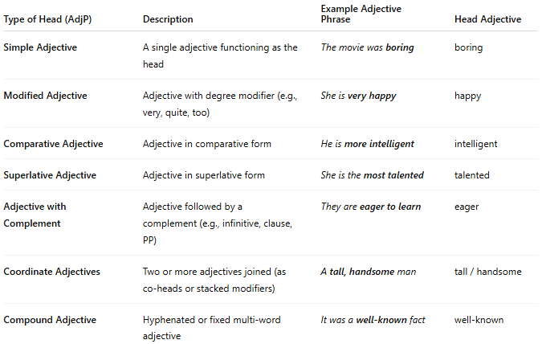
Type of Head (AdjP) | Description | Example Adjective Phrase | Head Adjective
Simple Adjective | A single adjective functioning as the head | The movie was boring | boring
Modified Adjective | Adjective with degree modifier (e.g., very, quite, too) | She is very happy | happy
Comparative Adjective | Adjective in comparative form | He is more intelligent | intelligent
Superlative Adjective | Adjective in superlative form | She is the most talented | talented
Adjective with Complement | Adjective followed by a complement (e.g., infinitive, clause, PP) | They are eager to learn | eager
Coordinate Adjectives | Two or more adjectives joined (as co-heads or stacked modifiers) | A tall, handsome man | tall / handsome
Compound Adjective | Hyphenated or fixed multi-word adjective | It was a well-known fact | well-known

✅ Notes:
# Source: AI Source: Provided by: [Data Path: Persons Table -> ID Column: 1, Name_En Column: Motasem Essam] -> From: [Chatgpt (GPT‑5 Mini)] on [8/7/2025]
- The head of an adjective phrase is always the main adjective — it carries the key descriptive meaning.
- Modifiers like very, quite, too do not function as heads, but intensify the meaning of the head.
- Complements like to learn, that he lied, or with the plan often follow adjectives and complete their meaning.

